CS 383 Midterm

1. Volatile memory is temporary memory. Anything stored on it will be erased when the power source is disconnected from it. RAM is an example of volatile memory. Non Volatile memory can hold information regardless of if its connected to power or not, it is not temporary and can be used for long term storage solutions. ROM is an example of non-volatile memory.
2. ALU stands for Arithmetic logic unit. CU stands for control unit. A register is a small part of the CPU that is for holding of data to be used by the processor. This data could be an instruction, memory address, bits, or characters. The purpose of the instruction register is to hold the instruction that is currently being executed by the processor.
3. The fetch execute cycle is a process in which a computer gets an instruction from memory, processes the instruction and then actually performs the instructed task. The clock speed of a CPU is important because it dictates how fast a core of that CPU can process instructions. Each Hz means that one fetch execute cycle can be run in that second so a CPU that clocks at 4.77 MHz can execute 4770000 cycles per second.
4. Implementing different separate fetch and execute units in a CPU increases the speed of the processor, like in a multi-core processor.
5. A superscalar processor can make use of multiple execution units to run multiple instructions during a clock cycle.
   1. Flash memory is faster than hard disk storage. The computer can access it faster. Flash storage also uses less power than hard disk storage. The speed of data retrieval doesn’t depend on the information location on the drive with flash memory. Flash memory is less prone to mechanical failure as well.
   2. Hard disk memory is generally cheaper and available in larger storage capacities.
   3. Over RAM, both hard disk and flash storage is not temporary and can be stored for long periods of time
   4. RAM is extremely faster than flash and hard disk storage.
6. L2 caches have more money than L1 caches because it is faster to decode the L1 cache and use the info stored inside. L2 caches are bigger to store more information so that in the event of a cache miss in L1, the computer can search through L2.
7. Lmao
8. An interrupt is a signal that tells the computer operating system to stop so that it can figure out what to do next. Because of interrupts the computer can pause on task and move on to a different task, effectively allowing the machine to multitask. This functionality would be lost without interrupts.
9. A polled interrupt signals to the computer when an I/O device is ready to be read. Polling is the process where a computer will wait and check on an I/O device or program to see what state they are in or if they still need to be communicated with. The computer must take the interrupt and then poll the devices to find out where the signal came from. This is called polled interrupt processing. Polling is checking on the computer’s environment while polled interrupt processing is for finding a specific signal from a specific device.
10. A keyboard generates data to be used as input on the spot with every keystroke. Data on a hard disk already exists on the drive when it is connected as an input device
11. Over time, the upgrade from 16 bit to 32 bit to 64-bit architecture has allowed CPUs to be able to address more and more memory. Now with 64 Bit, CPUs can address more than 4 GB of memory. CPUs have also become so much smaller in size as engineers continuously find out how to make the transistors they run on smaller. Currently, modern consumer CPUs are 14nm and 10nm is on the way. This allows for a lower profile less power consumption, which also over time has improved drastically. The creation of the multicore processor has driven speed and clock times significantly up as dual, quad, hexa and octa core processors become mainstream. Multiple cores allow for the CPU to execute multiple fetch cycles at time and process large amounts of information at once.
12. The problem with CPU design and Moore’s law is that even though engineers are consistently working on making CPU transistors smaller for smaller and faster processors, eventually due to the laws and nature of physics, it will become physically impossible to make smaller transistors and we will not be able to design smaller processors.

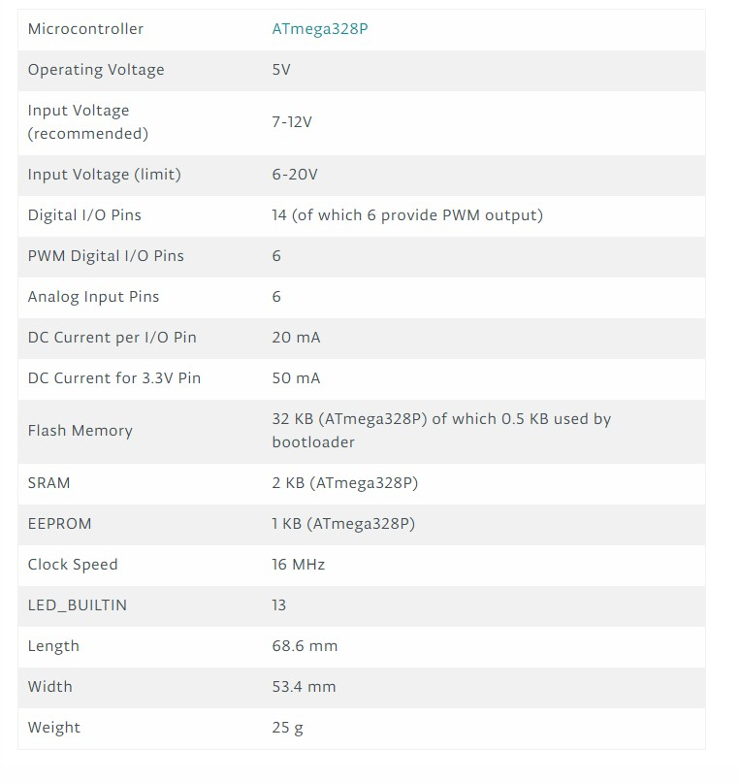

; Midterm.asm

;

; Created: 10/15/2017 10:10:49 PM

; Author : Tyler

;

.include "m328Pdef.inc"

; Use r16 for X,

start:

ldi r16, 5

ldi r17 ,2

ldi r18, 3

ldi r19, 4

mul r16, r16

mov r20, r0

mul r20, r17

mov r21 ,r0

add r18, r19

mov r22, r0

sub r21, r22

mov r23, r0

jmp END

END: